Autumn 2023
Newsletter

In this issue

Penny Brohn in August
BAWA in September
BT Health & Wellbeing Day
A Walk on the Wild Side
October PSA Testing Day
2024 Meeting Programme
Prospect Questionnaire
Membership Renewals
Nuclear Drug Treatment
The Vision Trial
New UTI Drug
A Message from the NHS
Cycling for Fitness
Our Newsletters Future
Next meetings
PROSPECT is a local support group for prostate cancer patients, their carers and friends.
We provide help support and information and our newsletter is published four times a year. Any articles you think would interest our members please email to David Casley at:
prospect.bristol@gmail.com

PENNY BROHN IN AUGUST
Traditionally we have always had a July summer lunch at Penny Brohn followed by a talk on a related subject. This year we decided to make it a full day event in August.
We met at 10.30 for refreshments and were given a tour of the buildings and gardens.
Before lunch Kim Wilcox gave a talk on nutrition and after lunch Elizabeth Moore, the head gardener, talked to us about the therapeutic effects of gardening and enjoying plants.
Finally we had a talk by
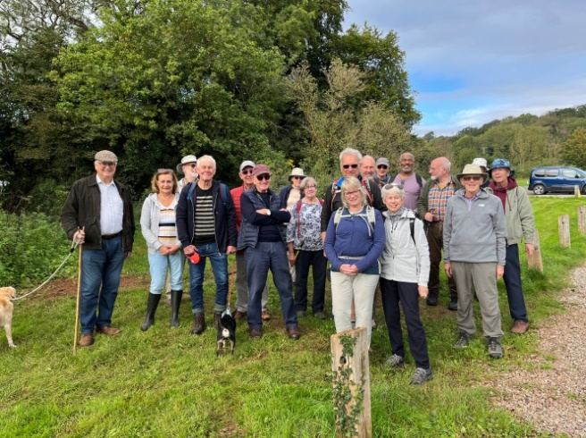
Nicky Robinson on the services provided by Penny Brohn.
A great day out and one we are planning to repeat next year.

BAWA IN SEPTEMBER
This was the first of our evening meetings since the spring and it was good to meet many members we had not seen since April.
Arthur Quinn, the manager of the Macmillan Wellbeing Centre at Southmead, gave us a talk on the work of Macmillan not only in Bristol but throughout the country.
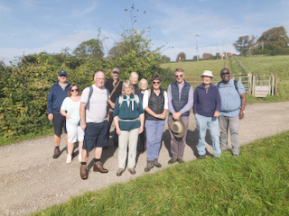
Arthur joined us for the buffet afterwards. It was good to talk and catch up with members’ news resulting in the evening extended well past our normal finishing time.

BT HEALTH & WELLBEING DAY
Jeff Allen and Bernard Smyth organised a Prospect prostate cancer

awareness stand at this BT event early in September.
It was held at BT’s offices in central Bristol and our stand was one of many there to help BT’s staff understand the importance of self-management of health and wellbeing.

A WALK ON THE WILD SIDE
Chris Millett, our retired professional guide and botanist, organised another fascinating walk for our members on the first Friday in October. Chris limits the number taking part to about 15 so as not to lose anybody!

The Friday walkers
The numbers wanting to take part were such that Chris organised a second walk the following Monday.

The Monday walkers
We started from the National Trust carpark at Tyntesfield House and walked to explore the rewilding of Watercress Farm that now forms part of the Belmont organic farm.
The rewilding involves removing internal fences, rewetting fields and allowing animals to roam the area.
We met pigs and cows and wondered at the drainage ponds recently created.
After a walk of about 6km we arrived back at Tyntesfield for a welcome lunch.
Chris will be organising another two walks next year in April and October so watch out for the emails inviting you to join us.

OCTOBER PSA TESTING DAY

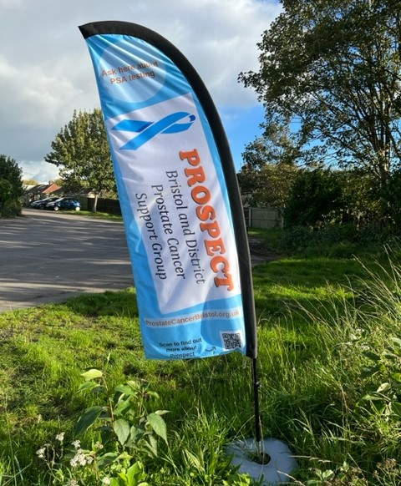

Our banner flag welcoming men to the PSA testing day.

Thank you for your support!
We are happy to report that on Saturday 14th October 2023 Prospect hosted its first Prostate Cancer Awareness and PSA Testing event. The event was held at The Rose Green Centre in Whitehall, east central Bristol.
Between 10am and 4pm over 160 men arrived to pre-allocated appointments for blood tests to be taken by two phlebotomists provided by Graham Fulford Charity Trust (GFCT). In addition, throughout the day men and their partners had opportunities to attend stalls provided by Macmillan, Penny Brohn UK, Diabetes UK and, of course, Prospect. There were also leaflets available provided from Life Cycle and Artlift.
Helping attendees to engage in these stalls, guiding them around the venue, and holding many constructive and informative conversations were our 30 volunteers, comprising the Prospect Committee, helpers from the Prospect membership and partners.
Light refreshments, in the form of a broad range of drinks and diverse snacks such as sandwiches, samosas and patties, were available throughout the event.
We were pleased that donations received on the day amounted to over £403.
More information on the event will be provided in our next Prospect newsletter, after the feedback forms completed at the event and the GFCT results data are analysed.
Prospect acknowledges the generous funding received from Macmillan, who awarded a Support Grant, and a donation from The Kendleshire Golf Club, without which the event would not have taken place.
The event was planned and organised by a working group comprising our Prospect members; Jeff Allen, Nigel Derrett, Mark Wilcox and Ray Westcott. Thanks must also go to Sharon Allen and Carole Webb who worked all day in the kitchen preparing the light refreshments.

2024 MEETING PROGRAMME
The following is a list of Prospect’s planned meetings for next year. Please take time to note them in your diary and a programme card is included with this newsletter. Changes might occur so please check our website closer to the dates for any alterations.
The programme is as follows:

On the first Thursday of each month we hold coffee mornings between 10am and noon at Penny Brohn Bristol Cancer Help Centre, Chapel Pill Lane, BS20 0HH to discuss experiences of prostate cancer treatment.

Similarly on the third Tuesday of each month we hold afternoon meetings between 2pm and 4pm at the Macmillan Centre on the Southmead Hospital site.

BAWA meetings are usually held at 7pm on a weekday at Bristol Aerospace Welfare Association (BAWA) Southmead Road Filton Bristol BS34 7RG. The meetings are followed by a buffet and informal discussion and finish at about 9.30pm.

Family and friends are always welcome to all of our meetings.

Thursday 11 January – Committee meeting
Tuesday 23 January – BAWA meeting with a speaker

Monday 11 March – BAWA informal meeting

Thursday 11 April – Committee meeting
Friday 19 April – Spring walk and lunch
Tuesday 23 April – Our AGM at BAWA with a speaker

Friday 10 May – Tour of Bristol Botanic Gardens & lunch

Friday 28 June – Bristol docks walk and lunch

Tuesday 23 July – Penny Brohn day event with lunch
Thursday 25 July – Committee meeting

Tuesday 10 September – BAWA informal meeting

Friday 11 October – Autumn walk and lunch
Thursday 24 October – Committee meeting

Monday 11 November – BAWA meeting with a speaker

December – Christmas lunch
PROSPECT QUESTIONNAIRE
Early in 2023 the Prospect Committee agreed for Jeff Allen to gather data that would help inform Prospect’s future planning and development.
A pilot questionnaire was run during the Prospect coffee morning at Penny Brohn on Thursday 2 February. During this pilot session about 35 attendees provided important initial feedback by completing 22 forms, highlighting the need to include the wider membership. The pilot form was used as a template and modified before canvassing the 227 members and friends on the Prospect database.
The results of the questionnaire are included on a separate sheet enclosed with this newsletter.

MEMBERSHIP RENEWALS
November is the month when we hope all of our members will renew their membership of Prospect. Perhaps some of our friends will join for the first time in recognition of the work we do in promoting mens health.
As a voluntary organisation we do not receive any outside funding and rely on the generosity of our members, friends and local organisations to provide the money we need to operate each year which is about £4,000.
Previously we have sent out a personalised renewal form with our newsletter. However this year our printers have been franking and posting out our newsletters to save time and money so we cannot include a personalised renewal form with this newsletter.
You will now receive a renewal email asking you to re-join us and only complete a new membership form attached to the email if your details have changed.
This form should be sent to Robert Bennett, our membership secretary, at his home address printed on the top of the form.
We hope you will pay your membership subscription by bank transfer and bank details are given on the membership form and email. Alternatively send Robert a cheque or bank notes.
If you do not receive a membership email this is because you have recently joined us and your membership will continue to November in 2024.

NUCLEAR DRUG TREATMENT
In our spring newsletter we wrote about Theranostic Treatment and Lutetium PSMA therapy. More on this therapy was written in September by Eleanor Hayward, health correspondent in The Times. She wrote:
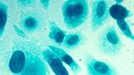
“Thousands of men each year stand to benefit from a revolutionary prostate cancer drug that marks the beginning of a ‘new era of cancer therapy’.
“The drug, called Lu-PSMA, is delivered via an intravenous drip and then ‘seeks and destroys’ tumours by targeting the cancer with radioactive
chemicals from inside the body. It is the first of a new class of ‘nuclear medicine’ treatment.”
Scientists told The Times that successful trial results had paved the way for similar drugs to be used in other cancers including breast, lung and pancreatic tumours.
Because the drug only binds to cancer cells, healthy tissue is spared, so patients avoid the brutal side-effects from other treatments such as chemotherapy and radiotherapy.

THE VISION TRIAL
Prostate Cancer UK In their 2021 article reported about the drug 177Lu-PSMA-617 developed by the University of Heidelberg in Germany.
The VISION trial looked at a new type of cancer treatment, called 177Lu-PSMA-617 (also known as Lutetium-177 or lutetium therapy). What’s exciting about lutetium therapy is that it’s delivered straight to cancer cells through an innovative mechanism that reduces side-effects and can help extend the life of men with advanced prostate cancer.
Advanced prostate cancer, also called metastatic or late-stage cancer, is cancer that has spread from the prostate to other parts of the body, most commonly the bones or lymph nodes. While there are treatments available to help manage symptoms or keep the cancer under control, it’s not possible to cure advanced prostate cancer.

Image of advanced prostate cancer cells

VISION is a Phase 3 trial, the last stage needed before the treatment can be brought into normal practice. The treatment won’t be available immediately as it still needs to be licenced to confirm its safety and to be appraised by the National Institute for Health and Care Excellence (NICE). That said, the positive trial results are a great step towards lutetium therapy being available for men with late-stage prostate cancer.
Prostate Cancer UK is working hard with the NHS, researchers, and health experts to help this treatment reach the men across the UK who need it.
NEW UTI DRUG
A new antibiotic that is better at treating urinary tract infections (UTI) than current drugs may be available in a year.
Gepotidacin is an antibiotic made by GSK and is undergoing trials.
Data from the UTI arm of the study show the drug is almost 15% better than nitrofurantoin (MacroBID) the antibiotic currently used.
Data show the antibiotic was successful in 58.5% of patients compared to 43.6% for nitrofurantoin.
Prof Florian Erich Wagenlehner, principal investigator for one of the trials, said: “These results are a significant step forward in an area that has seen little innovation for decades.”
The full results are expected to be published later this year.

A MESSAGE FROM THE NHS
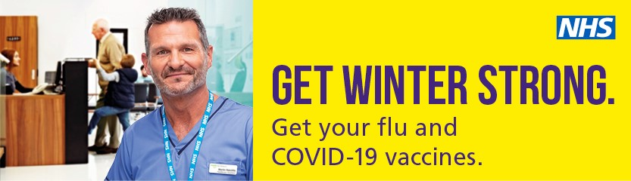
Justin Warr, communications and engagement lead at the NHS, has asked us to publish this message:
The NHS is offering Covid-19 and flu vaccines to prostate cancer patients and those at greater risk of serious illness this autumn and winter. Over the last few years, these vaccines have kept tens of thousands of people out of hospital and helped to save countless lives.
Getting your vaccines ahead of winter are among the most important things you can do to keep yourself and others around you safe and to get ‘winter strong’.
More sites than ever before are offering the vaccine to make it as easy and convenient as possible to get protected. This includes pharmacies, GP surgeries and community vaccine centres in Bristol, North Somerset and South Gloucestershire. Some of these local clinics are ‘walk-in’ meaning no prior booking is needed.
People who can get both vaccines free through the NHS include everyone aged 65 and above, pregnant women, care home residents, people aged 6 months old or above with certain health conditions, frontline health and care staff, unpaid carers and household contacts of those at higher risk.
You are encouraged to come forward as soon as possible due to the risk of the new variant, for the best possible protection. It is important to top up your protection, even if you have had a vaccine or been ill with flu or Covid-19 before, as immunity fades over time and these viruses change each year. You may already have been contacted by your GP surgery or local
NHS service. To find out more, and book your vaccines, please ring 119 for free, use the NHS App, or visit the website www.grabajab.net
Booking your vaccines is quick and easy; it usually takes just a few minutes.

CYCLING FOR FITNESS
Many of our members cycle to keep active.
We have recently had BAWA meetings about the trial of electric bikes to aid activity and fitness in prostate cancer patients.
If you would be interested in joining in with other Prospect members to arrange cycling events we have a member who may be willing to organise this. Just send an email to Prospect and we will compile a list of interested members.

OUR NEWSLETTERS FUTURE
In our winter newsletter, sent out in January, we appealed for somebody to help in the production of this newsletter. Unfortunately nobody responded.
It’s not a very arduous job but does involve perhaps about a weeks’ time every three months. No experience is necessary but if you have some publishing or word processing skills so much the better.
Early next year our editor may be moving house so won’t be able to compile the next newsletter due out in January or early February.
Unless we have a volunteer this may be the last newsletter for some time. Please do consider if you can help us.

NEXT MEETINGS

On the first Thursday in every month we hold coffee mornings between 10am and noon at Penny Brohn UK, Bristol Cancer Help Centre, Chapel Pill Lane, Pill, Bristol BS20 0HH.
On the third Tuesday in every month come for afternoon tea and cake between 2 and 4pm at the Macmillan Wellbeing Centre on the Southmead Hospital site.
Please join us and share your experiences of treatment with newly diagnosed patients.

You will probably receive this newsletter after our November BAWA meeting so the next is on the 23 January 2024 starting at 7.00pm and of course concludes with the famous BAWA buffet.

Check our website
www.prostatecancerbristol.org.uk
for details of any update in meeting arrangements.

Contact us by email at
prospect.bristol@gmail.com
or telephone our “Tackle” helpline
0800 035 5302.

